Contents
Selection of Core Use Cases for User Interface Design 3
UC-01 – Book appointment 3
UC‑02 – Register patient information 4
UC-03 – Manage doctor schedule 4
UC‑06 – Cancel appointment 5
UC-07 – Make payment 5
Assumptions 6
User Interface List for Core Use Cases 7
Mapping of User Interfaces to Use Cases 9
User Interface Descriptions 10
System Interface List 12
Relationship to Core Use Cases 14
Overall Menu and Navigation Concept 15
Main Window Structure 15
Top Menu Bar Concept 15
Role-Specific Navigation Panels 16
Global Menu Architecture (Java GUI) 17
Final Menu Hierarchy Structure 17
Traceability to A0 and A1 20
Menu Hierarchy and Navigation Flow 21
Menu Grouping Table 21
Storyboards for Core Use Cases 24
Storyboard – UC-01 Book Appointment 24
Storyboard – UC-02 Register Patient Information 25
Storyboard and Screen Design for UC‑06 – Cancel Appointment 27
Storyboard – UC-07 Make Payment 28
Storyboard UC‑03 Manage Doctor Schedule 29
UI/UX Design Guidelines for Java GUI and Figma 31
Visual Theme and Color Palette 31
Buttons, Forms, and Validation 32
Feedback, Status, and Error Messages 33
Application to Figma and Java Implementation 34
Application to Figma Prototypes (UI Screens) 34
Figma Screens (UI01–UI12) 35
Authentication 35
Figure 1: UI01 – LoginFrame (Figma) 35
Dashboards 36
Figure 2: UI02 – PatientDashboardFrame (Figma) 36
Figure 3: UI03 – ReceptionistDashboardFrame (Figma) 36
Figure 4: UI04 – DoctorDashboardFrame (Figma) 37
UC-01 Book Appointment flow 37
Figure 5: UI05 – BookAppointmentPanel (Figma) 37
Figure 6: UI06 – AppointmentDetailsDialog (Figma) 38
UC-02 Register Patient flow 38
Figure 7: UI08 – PatientSearchDialog (Figma) 38
Figure 8: UI07 – RegisterPatientFormFrame (Figma) 39
UC-03 Manage Doctor Schedule flow 39
Figure 9: UI09 – DoctorScheduleManagementFrame (Figma) 39
Figure 10: UI09b – Slot Details Open (State Variant) (Figma) 40
UC-06 Cancel Appointment flow 40
Figure 11: UI10 – CancelAppointmentPanel (No Selection State) (Figma) 40
Figure 12: UI10a – CancelAppointmentPanel (Row Selected State Variant) (Figma) 41
Figure 13: : UI10a- CancelAppointmentPanel(Confirm Modal) (Figma) 41
UC-07 Make Payment flow 42
Figure 14: UI11 – PaymentOverviewFrame (Figma) 42
Figure 15: UI12 – PaymentProcessingDialog (Figma) 42

Selection of Core Use Cases for User Interface Design
We selected five core use cases from the Healthcare Management System:
UC‑01 Book appointment
UC‑02 Register patient information
UC‑03 Manage doctor schedule
UC‑06 Cancel appointment
UC‑07 Make payment

These use cases were chosen because they:
- Cover the primary operational flows of the system (registration, appointment management, and billing).
- Involve rich user–system interaction, which is essential for menu design, screen layout, and interaction flow design.
- Map directly to the key domain classes identified in Deliverable 3 (Patient, Doctor, Appointment, MedicalRecord, Room, Bill, Prescription).
- They are already supported by activity diagrams, system sequence diagrams, and state machines, ensuring traceability between analysis and design.

UC-01 – Book appointment
- Primary actor: Patient
- Supporting actors: HealthcareSystem, optionally Receptionist
- Brief description:
The patient (or the receptionist on behalf of the patient) searches for available doctors and time slots, selects a preferred slot, and submits a booking request. The system validates the slot, reserves the corresponding room/slot, and creates an Appointment. Depending on clinic policy, the system may also initiate pre-payment as part of the booking process.
- Rationale for inclusion as a core use case:
Booking appointments is central to the healthcare system’s purpose. This use case links several core domain classes (Patient, Doctor, Appointment, Room) and contains non-trivial decision logic (slot availability, alternative proposals, optional pre-payment). It is therefore a key driver for designing intuitive booking screens, filters, and confirmation views in the user interface

UC‑02 – Register patient information
- Primary actor: Receptionist
- Supporting actors: HealthcareSystem
- Brief description:
- The receptionist opens the patient registration function, enters or updates patient demographic and clinical details, and submits the information. The system validates the data and, on success, creates or updates the corresponding Patient and MedicalRecord entries, returning a confirmation message. In case of invalid data, the system returns detailed validation errors for correction.
- Rationale for inclusion as a core use case:
- Patient registration is a prerequisite for almost all other operations in the system, including appointment booking, treatment documentation, and billing. This use case exercises form‑based data entry, validation feedback, and usability aspects of the interface. It is directly connected to the core domain classes Patient and MedicalRecord defined in Deliverable 3.

UC-03 – Manage doctor schedule
- Primary actor: Doctor
- Supporting actors: HealthcareSystem
- Brief description:
The doctor accesses their schedule, views existing time slots, and performs updates such as adding new availability, blocking time ranges, or modifying existing slots. The system checks for conflicts (e.g., overlapping slots, invalid time ranges) and either applies the changes or returns detailed conflict information for correction.
- Rationale for inclusion as a core use case:
The availability managed in this use case directly determines which appointment slots can be booked or cancelled. It requires clear visualization of time-based data (e.g., calendars, tables), as well as intuitive editing and conflict-resolution feedback. The use case is tightly connected to the Appointment lifecycle and the scheduling/slot concepts in the domain model.

UC‑06 – Cancel appointment
- Primary actor: Patient or Receptionist
- Supporting actors: HealthcareSystem, NotificationService
- Brief description:
- The actor selects an upcoming appointment and requests its cancellation. The system evaluates the applicable cancellation policy (for example, whether the request is more than 24 hours before the appointment). If allowed, the system updates the Appointment status (e.g., Cancelled or Late‑cancelled), releases the associated room/slot, and sends notifications to the patient and doctor. If the policy is violated, the system may show warnings or penalties before final confirmation.
- Rationale for inclusion as a core use case:
- Appointment cancellation is a frequent real‑world operation with important policy rules and side effects. The user interface must support clear appointment selection, explanation of policy constraints, and confirmation dialogs. This use case is closely related to the Appointment lifecycle, resource reuse (Room/slot), and notification behavior.

UC-07 – Make payment
- Primary actor: Patient
- Supporting actors: HealthcareSystem, external Payment Gateway
- Brief description:
The patient views a list of unpaid bills, selects a bill to settle, chooses a payment method, and confirms the payment. The HealthcareSystem sends a payment request to the external Payment Gateway and receives an approval or failure response. On approval, the system updates the Bill status to Paid, records transaction details, and shows a success confirmation. On failure, it displays an error message and may offer options to retry or cancel the attempt.
- Rationale for inclusion as a core use case:
This use case is central to the financial processes of the system. It directly interacts with the Bill class and the Bill lifecycle state machine (PendingPayment, Paid, Failed, Overdue). The user interface must clearly display bill details, payment options, and error/retry behavior. As a result, it provides a strong basis for designing payment screens, confirmation dialogs, and integration feedback forms.

Assumptions
The following assumptions underpin the design decisions in this deliverable:
- User Roles:
The system supports three primary roles—Patient, Receptionist, and Doctor—each with role-specific dashboards and permissions.
- External Service Availability:
External integrations (Payment Gateway, Notification Service, Reporting Service, External Patient System) are assumed to be available via secure APIs. If unavailable, the system logs failures and continues the main workflow where safe.
- Cancellation Policy:
Appointment cancellation is governed by a time-based threshold (e.g., 24 hours), which may trigger warnings or penalties. The UI includes appropriate confirmation dialogs.
- Reporting Output:
Reports are generated electronically (PDF or Excel format). External distribution requires user consent and audit logging.
- Java GUI Target:
The user interface is intended to be implemented using Java GUI frameworks (Swing or JavaFX), aligned with the A4 architecture.
- Traceability:
All UI and system interface designs remain traceable to Deliverable 3 artifacts, including use cases, system sequence diagrams (SSDs), activity diagrams, sequence diagrams, and state machines.

User Interface List for Core Use Cases

UI ID | Screen Name (Conceptual Java GUI) | Related Use Case(s) | Primary Actor(s) | Purpose (Short Description) | Main Widgets / Contents (Conceptual)
UI-01 | LoginFrame | UC-01, UC-02, UC-03, UC-06, UC-07 | Patient, Receptionist, Doctor | Provide secure access to the system for all human users before they perform any operation. | Username and password fields, role selection or auto-detected role, “Login” and “Cancel” buttons, error message area.
UI-02 | PatientDashboardFrame | UC-01, UC-06, UC-07 | Patient | Central hub for patients to access booking, upcoming appointments, and billing options. | Welcome header, summary cards (next appointment, outstanding bills), navigation buttons/menus for “Book Appointment”, “My Appointments”, “My Bills”.
UI-03 | ReceptionistDashboardFrame | UC-01, UC-02, UC-06 | Receptionist | Central hub for receptionists to manage patient registrations and appointments. | Navigation menu for “Register Patient”, “Manage Appointments”, “Search Patient”, table of today’s appointments, quick-action buttons.
UI-04 | DoctorDashboardFrame | UC-03 | Doctor | Central hub for doctors to view and manage their schedule. | Calendar or list of today’s appointments, navigation to “Manage Schedule”, filters by date, status indicators.
UI-05 | BookAppointmentPanel | UC-01 | Patient, Receptionist | Support searching for doctors and available slots and submitting a booking request. | Filters (specialty, date range, doctor), table/list of available slots, slot details area, “Book” button, message/validation area.
UI-06 | AppointmentDetailsDialog | UC-01, UC-06 | Patient, Receptionist | Show detailed information of a specific appointment and allow context-specific actions (confirm, cancel). | Appointment summary (doctor, date/time, room, status), notes area, action buttons (e.g., “Cancel Appointment”, “Close”), policy message area.
UI-07 | RegisterPatientFormFrame | UC-02 | Receptionist | Capture new patient information and update existing patient records. | Text fields (name, DOB, contact info, insurance details), dropdowns (gender, blood type), text area for medical notes/allergies, “Save” and “Reset” buttons, validation error messages.
UI-08 | PatientSearchDialog | UC-02, UC-06, UC-07 | Receptionist | Allow searching and selecting an existing patient before registration update, appointment operations, or payment. | Search fields (name, ID, phone), results table, selection button, “New Patient” shortcut.
UI-09 | DoctorScheduleManagementFrame | UC-03 | Doctor | Enable doctors to view, create, modify, and block schedule slots. | Calendar or grid view of time slots, controls to add/edit/delete slots, status indicators (available, blocked, reserved), conflict warning area, “Save Changes” button.
UI-10 | CancelAppointmentPanel | UC-06 | Patient, Receptionist | List upcoming appointments and support cancellation with policy information. | Table of upcoming appointments (date/time, doctor, status), filters (date, status), details preview, “Cancel Selected” button, confirmation dialog with policy text.
UI-11 | PaymentOverviewFrame | UC-07 | Patient | Display a list of unpaid and paid bills for the authenticated patient. | Table of bills (ID, date, amount, status), filters (status, date range), total outstanding amount, “Pay Selected Bill” button.
UI-12 | PaymentProcessingDialog | UC-07 | Patient | Guide the user through the payment confirmation flow and show gateway responses. | Bill summary area, payment method selection (card, wallet, etc.), input fields for payment details (conceptual), “Confirm Payment” and “Cancel” buttons, status/progress indicator, success or error message area.

Mapping of User Interfaces to Use Cases
- UC-01 Book appointment
  - LoginFrame (UI-01)
  - PatientDashboardFrame (UI-02) or ReceptionistDashboardFrame (UI-03)
  - BookAppointmentPanel (UI-05)
  - AppointmentDetailsDialog (UI-06)
- UC-02 Register patient information
  - LoginFrame (UI-01)
  - ReceptionistDashboardFrame (UI-03)
  - PatientSearchDialog (UI-08)
  - RegisterPatientFormFrame (UI-07)
- UC-03 Manage doctor schedule
  - LoginFrame (UI-01)
  - DoctorDashboardFrame (UI-04)
  - DoctorScheduleManagementFrame (UI-09)
- UC-06 Cancel appointment
  - LoginFrame (UI-01)
  - PatientDashboardFrame (UI-02) or ReceptionistDashboardFrame (UI-03)
  - CancelAppointmentPanel (UI-10)
  - AppointmentDetailsDialog (UI-06)
- UC-07 Make payment
  - LoginFrame (UI-01)
  - PatientDashboardFrame (UI-02)
  - PaymentOverviewFrame (UI-11)
  - PaymentProcessingDialog (UI-12)

User Interface Descriptions
UI-01: LoginFrame
Authenticates users (Patient / Receptionist / Doctor) and routes them to the correct role dashboard.
Includes: username/password inputs, login action, inline error feedback.

UI-02: PatientDashboardFrame
Patient home hub providing access to booking, appointments, and billing.
Includes: summary cards (next appointment, outstanding balance) and quick navigation.

UI-03: ReceptionistDashboardFrame
Receptionist operational hub for registration and appointment management.
Includes: quick links (register/search patient, today’s appointments, cancel appointment) and data tables.

UI-04: DoctorDashboardFrame
Doctor hub for schedule visibility and schedule-management entry.
Includes: today’s schedule snapshot and navigation to Manage My Schedule.

UI-05: BookAppointmentPanel
Search and select appointment slots.
Includes: filters (specialty, doctor, date), available slots table/list, selection actions, and validation messages.

UI-06: AppointmentDetailsDialog
Confirms a selected appointment slot and displays the appointment summary and policies.
Includes: confirm/close actions and policy notes.

UI-07: RegisterPatientFormFrame
Create or update patient demographics and basic clinical data.
Includes: structured form sections, required-field validation, and save/reset actions.

UI-08: PatientSearchDialog
Search and select an existing patient record.
Includes: search criteria inputs, results table, select action, and New Patient shortcut.

UI-09: DoctorScheduleManagementFrame
View and edit doctor availability and blocked time.
Includes: calendar/grid view, add/edit/delete slot actions, and conflict/validation feedback.

UI-10: CancelAppointmentPanel
Select and cancel upcoming appointments with policy confirmation.
Includes: appointments table, filters, selected-row state, and confirmation modal.

UI-11: PaymentOverviewFrame
View bills and initiate payment.
Includes: bills table (paid/unpaid), filters, totals, and Pay Selected Bill action.

UI-12: PaymentProcessingDialog
Confirm payment and display payment gateway results.
Includes: bill summary, payment method input, progress indicator, success/failure feedback, and retry/cancel options.

System Interface List
SI ID | Interface Name | Type | Main Inputs to HealthcareSystem | Main Outputs from HealthcareSystem | Trigger / Initiation Mechanism
SI-01 | System Scheduler Interface | Internal scheduling / job trigger | Job configuration (e.g., frequency, enabled flags); time events (e.g., daily at 02:00) | Job start requests for batch use cases such as Send appointment reminders, Generate weekly report schedule, Generate monthly bill, Clean up expired slots, Update slot availability | Time-based triggers (cron-like schedule) configured by an administrator; the scheduler component invokes the HealthcareSystem at defined intervals.
SI-02 | NotificationService API | External service (notifications) | Lists of upcoming or cancelled appointments (patient contact data, doctor contact data, message templates, channels such as email/SMS) | Delivery status for each notification (sent, failed, partially delivered; error reasons when applicable) | Called by HealthcareSystem during use cases such as Book appointment, Cancel appointment, and Send appointment reminders. Triggered either by user actions (booking/cancellation) or scheduled jobs (reminder batch).
SI-03 | ReportingService API | External service (report generation) | Aggregated operational data (appointments per period, cancellations, revenue/billing summaries, schedule utilization metrics) and report parameters (date range, report type, format) | Generated report artifacts (e.g., PDF/Excel file references, dashboard summaries) and status information (success, partial failure, no data) | Initiated by the System Scheduler through use cases such as Generate weekly report schedule and other reporting jobs. Triggered on a scheduled basis or on administrator request.
SI-04 | Payment Gateway API | External payment service | Payment request messages containing bill identifier, amount, currency, patient/payment details, and selected payment method | Payment authorization responses (approved, declined, error) including transaction ID, authorization code, and error messages when applicable | Invoked by the HealthcareSystem during Make payment (UC-07) when the patient confirms a payment attempt from the UI. Triggered explicitly by user action.
SI-05 | ExternalPatientSystem API | External healthcare system / master patient index | Patient identifier or matching criteria (e.g., national ID, name + date of birth), optional filter parameters | Synchronized patient demographic and clinical data (updated name, address, contact info, allergy flags, etc.), error or conflict details in case of failures | Called from the Synchronize patient information extension use case, usually initiated by the Receptionist from within the registration or patient search functionality. Triggered on demand.
SI-06 | Appointment Slot Maintenance Interface | Internal maintenance job | Current schedules, appointments, and configuration rules for expiry and availability | Updated slot statuses (free, reserved, blocked, expired), summary of cleaned-up or adjusted slots | Triggered by the System Scheduler via the Clean up expired slots and Update slot availability maintenance use cases at configured times.
SI-07 | Billing Batch Interface | Internal batch / billing job | Completed treatments, consultations, and configured billing rules for the target period | New or updated Bill records, including calculated amounts and summaries of how many bills were generated; error messages if no billable items are found | Triggered by the System Scheduler during the Generate monthly bill use case, typically at the end of a billing period.

Relationship to Core Use Cases
- UC-01 Book appointment and UC-06 Cancel appointment
  - Use the NotificationService API (SI-02) to send confirmations and cancellation messages.
  - Indirectly depend on Appointment Slot Maintenance (SI-06) to keep slot statuses consistent.
- UC-02 Register patient information
  - May invoke the ExternalPatientSystem API (SI-05) to synchronize patient records when required.
- UC-03 Manage doctor schedule
  - Produces schedule data that is consumed by System Scheduler (SI-01) and Appointment Slot Maintenance (SI-06) for batch processing and slot cleanup.
- UC-07 Make payment
  - Directly integrates with the Payment Gateway API (SI-04) to authorize and record financial transactions.
  - Its results are later summarized by Billing Batch Interface (SI-07) and may be included in reports produced via ReportingService API (SI-03).

Overall Menu and Navigation Concept
The user interface of the Healthcare Management System follows a role-based main window with a shared top menu bar and contextual navigation panels. The goal is to provide a consistent structure for all actors (Patient, Receptionist, Doctor) while keeping frequently used tasks easily accessible for each role.

Main Window Structure
After successful login via LoginFrame, the system opens a role-specific dashboard frame:
- PatientDashboardFrame for patients
- ReceptionistDashboardFrame for receptionists
- DoctorDashboardFrame for doctors
Each dashboard is implemented as a main window that contains:
- A top menu bar with global menus (e.g., Home, Appointments, Patients, Billing, Help).
- A left side navigation panel (or tab bar) showing shortcuts to the most relevant functions for that role.
- A central content area where panels such as BookAppointmentPanel, RegisterPatientFormFrame, DoctorScheduleManagementFrame, or PaymentOverviewFrame are displayed.
This layout allows the application to maintain a uniform structure while customizing the available tasks and labels to each actor.

Top Menu Bar Concept
The top menu bar provides a consistent global navigation for all authenticated users. The following conceptual menu categories are defined:
- Home
  - Dashboard (patient, receptionist, doctor)
  - Profile / Logout
- Appointments
  - Book Appointment (UC-01)
  - My Appointments (view/modify)
  - Cancel Appointment (UC-06)
- Patients (primarily visible to Receptionist and Doctor)
  - Register Patient (UC-02)
  - Search / View Patient
  - Synchronize Patient Information (extension use case)
- Schedule (primarily visible to Doctor)
  - Manage Doctor Schedule (UC-03)
  - View Today’s Schedule
- Billing (primarily visible to Patient and administrative staff)
  - View My Bills (UC-07)
  - Make Payment (UC-07)
  - Billing History
- Reports / Maintenance (administrative / scheduler functions)
  - Generate Weekly Operational Reports
  - Generate Monthly Bills
  - Run Maintenance Jobs (e.g., Clean Up Expired Slots, Update Slot Availability)
- Help
  - User Guide
  - Contact Support
  - About
Each menu item opens the corresponding panel or frame in the central content area (for example, selecting “Book Appointment” loads BookAppointmentPanel inside the patient dashboard).

Role-Specific Navigation Panels
In addition to the top menu bar, a role-specific navigation panel is provided on the left side:
- PatientDashboardFrame
  - Quick links: “Book Appointment”, “My Appointments”, “My Bills”, “Make Payment Now”.
  - Summary widgets: next appointment, outstanding balance.
- ReceptionistDashboardFrame
  - Quick links: “Register New Patient”, “Search Patient”, “Today’s Appointments”, “Cancel Appointment”.
  - Summary widgets: number of appointments today, pending registrations.
- DoctorDashboardFrame
  - Quick links: “Today’s Schedule”, “Manage My Schedule”, “Pending Discharges” (if needed).
  - Summary widgets: number of appointments today, schedule utilization overview.
This dual navigation concept (top menu + side shortcuts) reduces click depth for frequent tasks while keeping the information architecture coherent across the system.

Global Menu Architecture (Java GUI)

Final Menu Hierarchy Structure
The final menu hierarchy is defined below. Visibility of some menus is role-dependent, but the overall structure remains consistent across dashboards.
1. Top-Level Menus and Items (JMenu / JMenuItem)
- Home (JMenu)
  - Dashboard (JMenuItem)
    - Loads the appropriate role-specific dashboard content into the central panel (PatientDashboardFrame, ReceptionistDashboardFrame, or DoctorDashboardFrame).
  - Profile (JMenuItem)
    - Opens a simple profile/settings view for the logged-in user.
  - Logout (JMenuItem)
    - Returns the user to LoginFrame and disposes of the current dashboard frame.
- Appointments (JMenu)
  - Book Appointment (JMenuItem) – UC-01
    - For Patient: loads BookAppointmentPanel inside PatientDashboardFrame.
    - For Receptionist: loads BookAppointmentPanel (configured for receptionist use) inside ReceptionistDashboardFrame.
  - My Appointments (JMenuItem)
    - For Patient: shows a list/table of the patient’s upcoming and past appointments (internally a panel using data from Appointment).
  - Cancel Appointment (JMenuItem) – UC-06
    - For Patient: loads CancelAppointmentPanel inside PatientDashboardFrame.
    - For Receptionist: loads CancelAppointmentPanel inside ReceptionistDashboardFrame.
  - (Optional) Appointment Details (JMenuItem)
    - Opens AppointmentDetailsDialog for a selected appointment from a list.
- Patients (JMenu) (visible primarily to Receptionist and Doctor)
  - Register Patient (JMenuItem) – UC-02
    - Loads RegisterPatientFormFrame content inside ReceptionistDashboardFrame central panel.
  - Search / View Patient (JMenuItem)
    - Opens PatientSearchDialog for locating a patient and viewing their basic information.
  - Synchronize Patient Information (JMenuItem)
    - Invokes the ExternalPatientSystem API (SI-05) from a dedicated panel or dialog, reflecting the synchronization extension use case.
- Schedule (JMenu) (visible primarily to Doctor)
  - Manage My Schedule (JMenuItem) – UC-03
    - Loads DoctorScheduleManagementFrame (or panel) inside DoctorDashboardFrame.
  - View Today’s Schedule (JMenuItem)
    - Shows a read-only view (table or calendar) of today’s appointments for the current doctor.
- Billing (JMenu) (visible to Patients and appropriate staff)
  - View My Bills (JMenuItem) – UC-07
    - Loads PaymentOverviewFrame content into the patient’s central panel, listing unpaid and paid bills.
  - Make Payment (JMenuItem) – UC-07
    - Opens PaymentProcessingDialog for the bill selected in PaymentOverviewFrame.
  - Billing History (JMenuItem)
    - Shows a list of past payments and bills for auditing and review.
- Reports / Maintenance (JMenu) (primarily for admin/scheduler roles)
  - Generate Weekly Operational Reports (JMenuItem)
    - Triggers UI to request a reporting period and forwards to ReportingService API (SI-03).
  - Generate Monthly Bills (JMenuItem)
    - Initiates the Billing Batch Interface (SI-07), reflecting the Generate monthly bill use case.
  - Run Maintenance Jobs (JMenuItem)
    - Opens a maintenance panel where an administrator can manually trigger tasks like Clean up expired slots and Update slot availability (SI-06).
- Help (JMenu)
  - User Guide (JMenuItem)
  - Contact Support (JMenuItem)
  - About (JMenuItem)
2. Role-Specific Side Navigation Panels (JPanel)
In addition to the JMenuBar, each dashboard frame contains a side navigation panel implemented as a JPanel with JButton or icon buttons:
- PatientDashboardFrame – Quick Actions
  - Book Appointment → opens BookAppointmentPanel
  - My Appointments → opens patient appointments list
  - My Bills → opens PaymentOverviewFrame content
  - Make Payment Now → opens PaymentProcessingDialog for selected bill
- ReceptionistDashboardFrame – Quick Actions
  - Register New Patient → opens RegisterPatientFormFrame content
  - Search Patient → opens PatientSearchDialog
  - Today’s Appointments → shows today’s appointment list
  - Cancel Appointment → opens CancelAppointmentPanel
- DoctorDashboardFrame – Quick Actions
  - Today’s Schedule → shows today’s schedule view
  - Manage My Schedule → opens DoctorScheduleManagementFrame
  - (Optional) Pending Discharges or other doctor-specific tasks
These quick-access buttons are consistent with the corresponding JMenuItem actions, but provide fewer clicks for the most frequent tasks.

Traceability to A0 and A1
- The menu categories and items are derived directly from the five core use cases (UC-01, UC-02, UC-03, UC-06, UC-07) defined in A0.
- Each significant menu item maps to one or more user interfaces from the UI list in A1 (e.g., Book Appointment → BookAppointmentPanel, View My Bills → PaymentOverviewFrame).
- This architecture ensures that Andrew can build a menu grouping table, Yassin can draw a UML use case–menu diagram, and all team members can design storyboards and Figma screens that are consistent with the final Java menu/navigation structure.

Menu Hierarchy and Navigation Flow
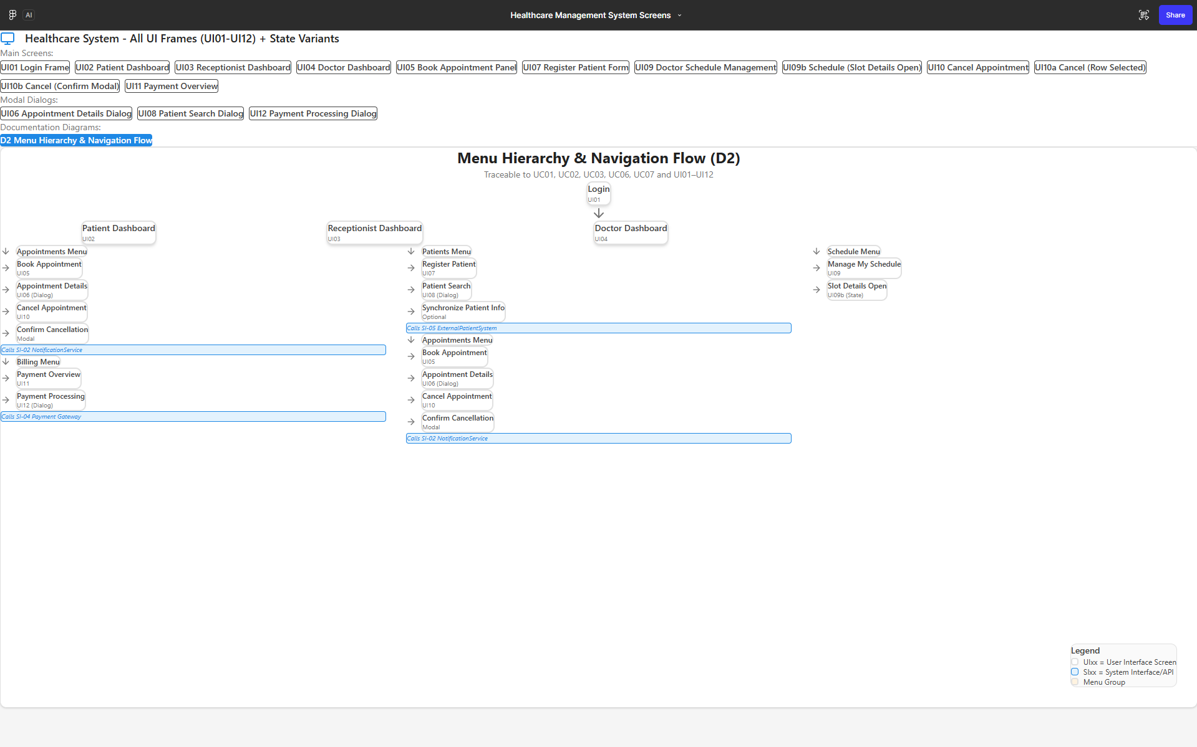

Menu Grouping Table
The following menu grouping table maps the five core use cases to menu categories, user roles, and frequency of use:

Use Case ID | Use Case Name | Menu Category (Top Menu) | Sub-Option / Screen | Primary Role(s) | Frequency of Use | Rationale for Grouping
UC-01 | Book appointment | Appointments | Book Appointment → BookAppointmentPanel | Patient, Receptionist | High | Booking is a core appointment operation, so it is grouped under the Appointments menu for quick access by both Patients and Receptionists. It is one of the most frequent tasks in daily work.
UC-02 | Register patient information | Patients | Register Patient → RegisterPatientFormFrame | Receptionist | Medium–High | Registration is primarily performed by Receptionists and directly concerns patient records, so it is grouped under Patients.
UC-03 | Manage doctor schedule | Schedule | Manage My Schedule → DoctorScheduleManagementFrame | Doctor | Medium | Managing schedules is performed by Doctors and directly affects appointment slot availability. It is logically grouped under Schedule to separate it from patient-oriented appointment tasks.
UC-06 | Cancel appointment | Appointments | Cancel Appointment → CancelAppointmentPanel | Patient, Receptionist | Medium–High | Cancelling appointments is also appointment-centric, so it is grouped under Appointments. It is regularly accessed when patients change plans or when cancellation policies apply.
UC-07 | Make payment | Billing | Make Payment → PaymentProcessingDialog (from PaymentOverviewFrame) | Patient | Medium | Payment actions focus on financial operations and invoices rather than scheduling. Therefore they are grouped under Billing.

This grouping ensures that frequently used operations (e.g., Book Appointment, Make Payment) are easily accessible from the top-level menu, while administrative and maintenance tasks are grouped under "Reports / Maintenance".

Storyboards for Core Use Cases
The following storyboards describe the user interaction flow for five core use cases. Each storyboard step corresponds to a concrete Java GUI event (menu selection, button click, table row selection, or dialog confirmation).

Storyboard – UC-01 Book Appointment
1. Login
- The patient logs in using LoginFrame.
- On successful authentication, the system opens PatientDashboardFrame.
2. Open Booking
- The user selects Appointments → Book Appointment from the main menu
—or— clicks the Book Appointment quick-action tile.
- The system loads BookAppointmentPanel inside the dashboard.
3. Search for Slots
- In BookAppointmentPanel, the user sets search filters (specialty, doctor, date, etc.)
and clicks Search.
- The system retrieves and displays matching available slots in a table/list.
4. Select Slot
- The user selects a slot row and clicks Book.
- The system validates that the slot is still available and opens AppointmentDetailsDialog.
5. Confirm Booking
- Inside AppointmentDetailsDialog, the user reviews appointment details
(doctor, date/time, room, policies) and clicks Confirm Booking.
- The system creates the Appointment and reserves the selected slot.
6. Return
- The system returns to PatientDashboardFrame.
- The next upcoming appointment summary is refreshed to show the new booking.

Storyboard – UC-02 Register Patient Information
- Login
• The receptionist logs in using LoginFrame (UI-01).
• Upon successful authentication, the system opens ReceptionistDashboardFrame (UI-03).
- Open Patient Registration
• From ReceptionistDashboardFrame, the receptionist selects Patients → Register Patient from the top menu (A4)
—or— clicks Register New Patient from Quick Actions.
• The system opens RegisterPatientFormFrame (UI-07).
- (Optional) Search Existing Patient
• If updating an existing record, the receptionist opens PatientSearchDialog (UI-08).
• The receptionist enters search criteria (name, national ID, or phone number).
• The receptionist selects a patient from the results.
• The system loads the selected patient details into RegisterPatientFormFrame for editing.
- Enter Patient Data
• The receptionist enters or updates patient information, including:
o Demographics
o Contact details
o Insurance information
o Basic medical information
• Mandatory fields are clearly marked with an asterisk (*).
- Validate and Submit
• The receptionist clicks Save Patient.
• The system validates the input, including:
o Missing required fields
o Invalid date formats
o Duplicate national ID
• If validation fails:
o The relevant field is highlighted in red (#E53935)
o An inline error message is displayed (e.g., “Please enter a valid date of birth.”)
o All entered data is preserved for correction
• If validation succeeds:
o The system creates or updates the Patient and MedicalRecord
o A success message is shown in green (#43A047): “Patient saved successfully.”
- (Optional) Synchronize with External System
• If configured, the receptionist selects Synchronize Patient Information.
• The system calls SI-05 ExternalPatientSystem API to retrieve matching demographic and clinical data.
• If the external system is unavailable:
o The failure is logged
o A non-blocking message is displayed
o Local patient data remains saved and usable
- Return
• The system returns to ReceptionistDashboardFrame (UI-03).
• The receptionist may proceed with appointment booking, billing, or other tasks using the saved patient record.

Storyboard and Screen Design for UC‑06 – Cancel Appointment
1. Login
- The user logs in using LoginFrame.
- Upon successful authentication, the system opens the appropriate dashboard (PatientDashboardFrame or ReceptionistDashboardFrame).
2. Open Cancel Appointment
- The user selects Appointments → Cancel Appointment from the main menu
—or— clicks the Cancel Appointment quick-action tile.
- The system loads CancelAppointmentPanel (UI10) inside the dashboard.
3. Filter Appointments
- In CancelAppointmentPanel, the user applies filters such as date range and status (e.g., Upcoming, Confirmed).
- The system retrieves and displays the matching appointments in a structured table with status tags/chips.
4. Select Appointment
- The user selects an appointment row from the table.
- The system displays a Selected Appointment summary card, including key details and cancellation policy notes.
5. Initiate Cancellation
- The user clicks Cancel Selected Appointment (red destructive-action button).
- The system opens ConfirmCancellationDialog to prevent accidental cancellations and displays policy warnings (e.g., “Cancelling within 24 hours may incur a penalty.”).
6. Confirm Cancellation
- Inside ConfirmCancellationDialog, the user clicks Confirm Cancellation.
- The system validates the request, updates the appointment status, releases the slot, and sends cancellation notifications (via SI02).
7. Return
- The system closes the dialog and reloads CancelAppointmentPanel with updated data.
- The dashboard's upcoming appointments section is refreshed to reflect the cancellation.

Storyboard – UC-07 Make Payment
1. Login
- The patient logs in using LoginFrame.
- The system opens PatientDashboardFrame.
2. Open Billing
- From PatientDashboardFrame, the user selects Billing → View My Bills
—or— clicks a My Bills quick link.
- The system loads PaymentOverviewFrame.
3. Select a Bill
- In PaymentOverviewFrame, the user may apply filters if needed.
- The user selects an unpaid bill, enabling the Pay Selected Bill action.
4. Start Payment
- The user clicks Pay Selected Bill.
- The system opens PaymentProcessingDialog, showing the bill details.
5. Confirm Payment
- In PaymentProcessingDialog, the user selects a payment method, enters any required data,
and clicks Confirm Payment.
- The system calls the external Payment Gateway and displays progress.
6. Result
- If payment succeeds:
  - A success message is shown in the dialog.
  - The bill is marked Paid, and the transaction is recorded.
- If payment fails:
  - An error message is displayed with options to retry or cancel.
- Upon closing the dialog, PaymentOverviewFrame refreshes the bill list and totals.

Storyboard UC‑03 Manage Doctor Schedule

1. Login
- The doctor logs in using LoginFrame (UI-01).
- The system opens DoctorDashboardFrame (UI-04).

2. Open Manage Schedule
- From DoctorDashboardFrame, the doctor selects Schedule → Manage My Schedule from the top menu (A4),
or clicks the Manage My Schedule quick action.
- The system opens DoctorScheduleManagementFrame (UI-09).

3. View Current Schedule
- In DoctorScheduleManagementFrame, the doctor views a calendar or grid of time slots.
- Each slot is clearly marked as:
  - Available
  - Booked
  - Blocked
- The doctor may:
  - Change the displayed week
  - Apply filters (date range, view mode)

4. Add Availability Slot
- The doctor clicks Add New Slot.
- The system opens a modal dialog to enter:
  - Date
  - Time range
  - Room
  - Optional recurrence
- The doctor confirms the entry.
- The system validates the slot for:
  - Correct time range
  - Overlap with existing slots
  - Room and time conflicts
If validation succeeds:
- The slot is created and displayed as Available.
If validation fails:
- An inline error message is displayed
(e.g., “Overlapping slot exists. Please choose another time.”).
- Entered data is preserved.

5. Block Time (Unavailability)
- The doctor clicks Block Time.
- The doctor selects a date/time range and provides a reason
(e.g., meeting, vacation).
- The system checks for existing booked appointments in the selected range.
If no booked appointments exist:
- The time range is blocked and displayed as Blocked.
If booked appointments exist:
- A warning message is displayed.
- The doctor must explicitly confirm before cancelling or rescheduling appointments.

6. Save Changes
- The doctor clicks Save Changes.
- The system displays a confirmation message indicating the schedule was updated successfully.
- The updated schedule becomes the authoritative source for future appointment bookings.

UI/UX Design Guidelines for Java GUI and Figma
This section defines the common visual and interaction guidelines for both the Java-based graphical user interface and the Figma prototypes of the Healthcare Management System. The goal is to ensure that all screens and storyboards produced by different team members remain visually consistent, usable, and aligned with the clinical context of the system.

Visual Theme and Color Palette
Overall Theme
- The application uses a light theme with high contrast and a clean, minimalist layout suitable for healthcare environments.
- Screens should avoid visual clutter and prioritize readability and clarity over decorative elements.
Color Palette
- Primary color:
  - Medical blue, e.g., #1E88E5.
  - Usage: primary buttons (e.g., “Save”, “Confirm Payment”), selected menu items, key highlights and links.
- Secondary color:
  - Neutral dark gray, e.g., #424242.
  - Usage: labels, secondary buttons, icons, borders, and non-critical elements.
- Accent colors for feedback:
  - Success: Green, e.g., #43A047.
    - Usage: success messages (“Appointment booked”, “Payment completed”), success icons or checkmarks.
  - Error / Warning: Red, e.g., #E53935.
    - Usage: validation errors, important warnings (late cancellation penalties, payment failures), error icons.
- Backgrounds:
  - Main window background: light gray or off-white, e.g., #F5F5F5.
  - Content panels, cards, and dialogs: white, #FFFFFF.
  - Tables and forms may use subtle zebra striping or light borders to separate rows without heavy lines.

Buttons, Forms, and Validation
Button Styles
- Primary buttons:
  - Background: primary blue (#1E88E5).
  - Foreground: white.
  - Used for the main action on the screen: “Save”, “Book Appointment”, “Confirm Payment”.
  - Only one primary button per main action area when possible.
- Secondary buttons:
  - Background: light gray or white with border.
  - Foreground: dark gray.
  - Used for actions like “Cancel”, “Back”, “Reset Form”.
- Destructive actions (e.g., “Cancel Appointment”):
  - Background: red (#E53935) or text in red with clear warning icon.
  - Require confirmation dialogs for irreversible actions.
Form Fields and Validation
- All input fields should have:
  - Clear, non-ambiguous labels.
  - Mandatory fields marked with an asterisk () and explained in a small legend (“ required”).
- Validation behavior:
  - When invalid input is submitted:
    - The specific field is highlighted (e.g., red border).
    - A short message is shown near the field (e.g., “Please enter a valid date”).
    - A general error summary may appear at the top of the form if multiple fields are invalid.
- Examples:
  - On RegisterPatientFormFrame, missing name or invalid date of birth should highlight those fields and show concise hints.
  - On PaymentProcessingDialog, invalid card data or missing method should result in clear error messages.

Feedback, Status, and Error Messages
- Success messages:
  - Use green text or icons with concise content.
  - Examples: “Appointment booked successfully.”, “Payment completed.”
- Info/warning messages:
  - Use neutral or orange/yellow warning styles for non-fatal issues.
  - Example: “Cancelling within 24 hours may incur a penalty.”
- Error messages:
  - Use red color and explicit wording:
    - Example: “Payment failed. Please check your card details or try again later.”
  - Where relevant, explain the next step: retry, choose another slot, contact support.
- Loading and progress indicators:
  - For operations that call external services (Payment Gateway, NotificationService, ReportingService):
    - Show a spinner, progress bar, or “Processing…” label.
    - Prevent multiple repeated clicks during processing.

Application to Figma and Java Implementation
- In Figma:
  - Use consistent components for buttons, text fields, and dialog layouts following the above rules.
  - Define shared styles for colors (Primary, Secondary, Success, Error) and text styles (Title, Subtitle, Body, Caption).
  - All storyboards and UI screens for UC-01, UC-02, UC-03, UC-06, and UC-07 should reuse these components and styles.
- In Java (Swing/JavaFX):
  - Mirror the Figma design in:
    - Color constants, fonts, and margins.
    - Panel layouts (e.g., BorderLayout/GridBagLayout/VBox/HBox equivalents).
  - The visual structure and interaction flow of each implemented screen (e.g., LoginFrame, BookAppointmentPanel, DoctorScheduleManagementFrame, PaymentOverviewFrame) should be clearly traceable back to its corresponding Figma design.

Application to Figma Prototypes (UI Screens)
To ensure consistency with the UI/UX guidelines (A5), each user interface identified in A1 has a corresponding Figma prototype. These prototypes serve as high-fidelity mockups for the future Java GUI implementation and illustrate layout, navigation, validation feedback, and modal interactions.
Implemented Figma Screens
- UI01 – LoginFrame
- UI02 – PatientDashboardFrame
- UI03 – ReceptionistDashboardFrame
- UI04 – DoctorDashboardFrame
- UI05 – BookAppointmentPanel
- UI06 – AppointmentDetailsDialog
- UI07 – RegisterPatientFormFrame
- UI08 – PatientSearchDialog
- UI09 – DoctorScheduleManagementFrame (including Slot Details state)
- UI10 – CancelAppointmentPanel (including Row Selected and Confirm Cancellation modal states)
- UI11 – PaymentOverviewFrame
- UI12 – PaymentProcessingDialog

Figma Screens (UI01–UI12)

Link to our Figma page:
https://www.figma.com/make/j2K7dM1Q5fVU8wwvharRq4/Healthcare-Management-System-Screens?node-id=0-4&t=donGXT4pOZiy8V7F-1

Authentication

Figure 1: UI01 – LoginFrame (Figma)
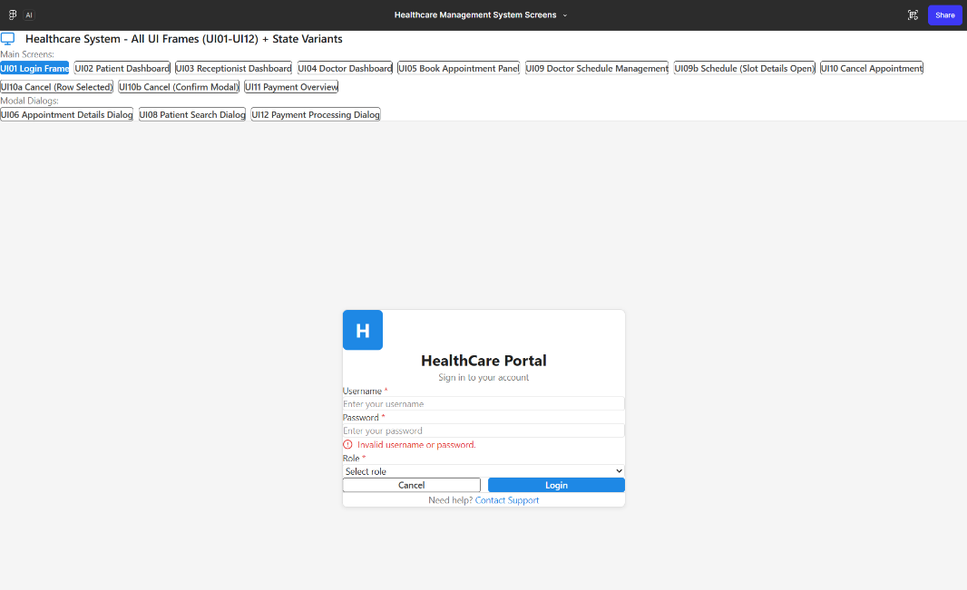

Dashboards

Figure 2: UI02 – PatientDashboardFrame (Figma)
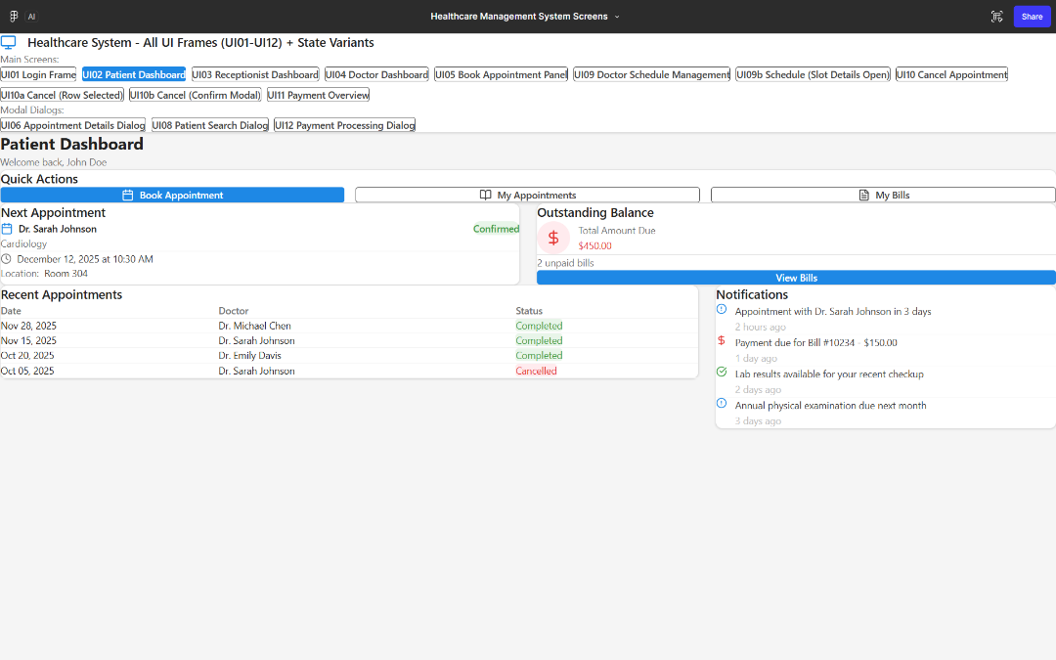

Figure 3: UI03 – ReceptionistDashboardFrame (Figma)
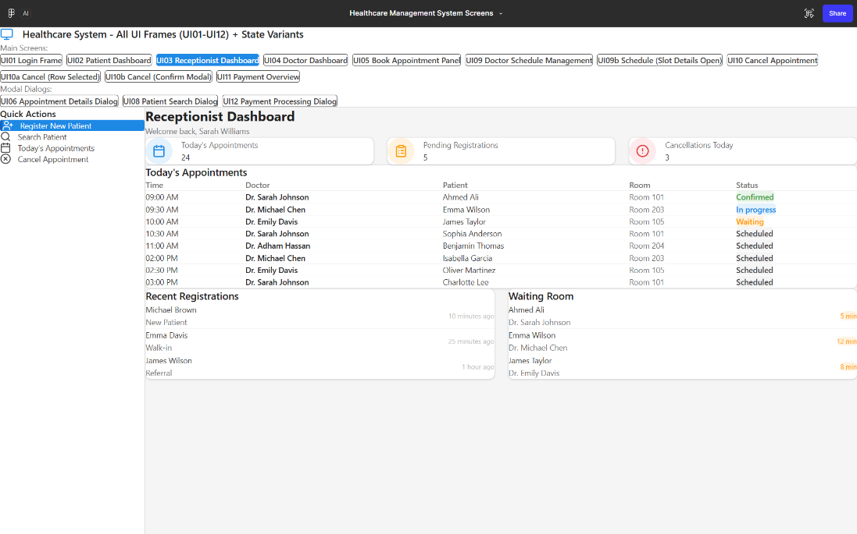

Figure 4: UI04 – DoctorDashboardFrame (Figma)
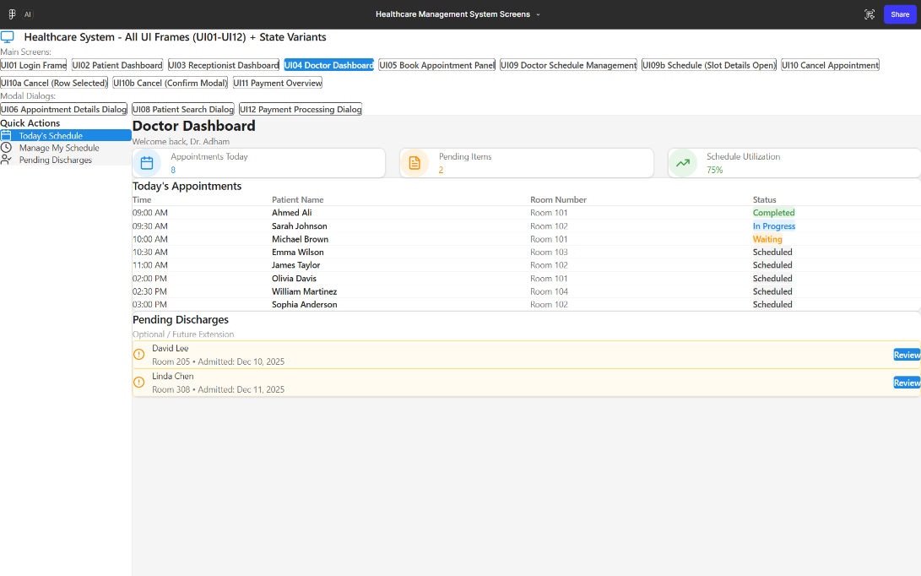

UC-01 Book Appointment flow

Figure 5: UI05 – BookAppointmentPanel (Figma)
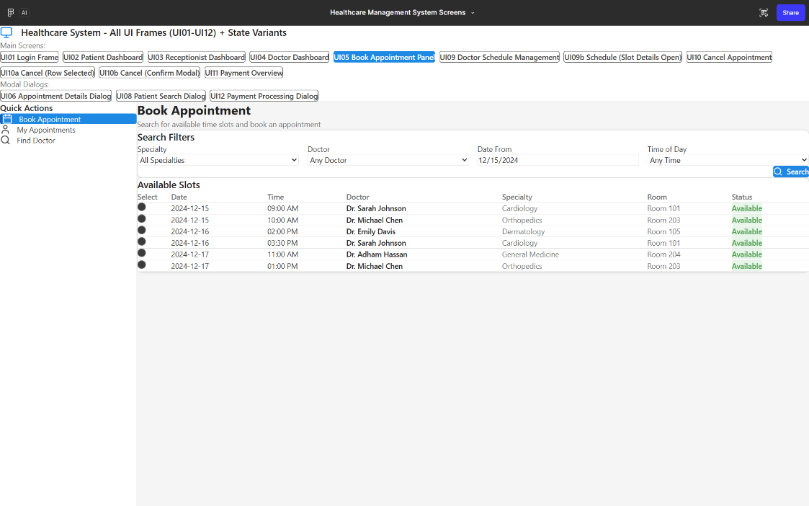

Figure 6: UI06 – AppointmentDetailsDialog (Figma)
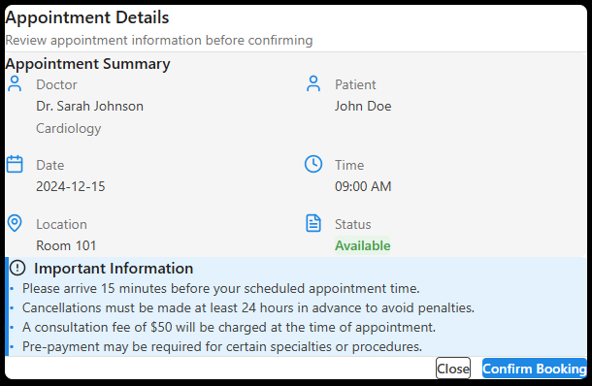

UC-02 Register Patient flow

Figure 7: UI08 – PatientSearchDialog (Figma)
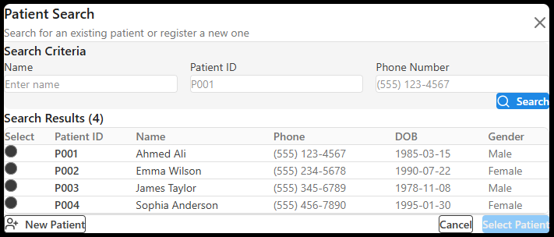

Figure 8: UI07 – RegisterPatientFormFrame (Figma)
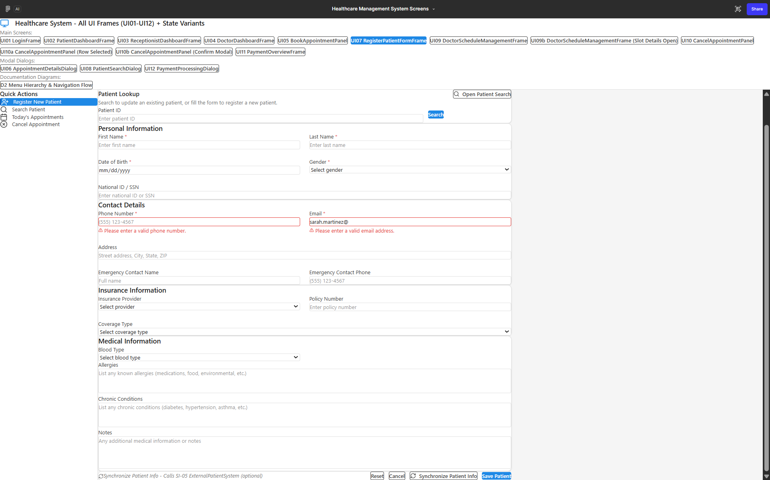

UC-03 Manage Doctor Schedule flow

Figure 9: UI09 – DoctorScheduleManagementFrame (Figma)
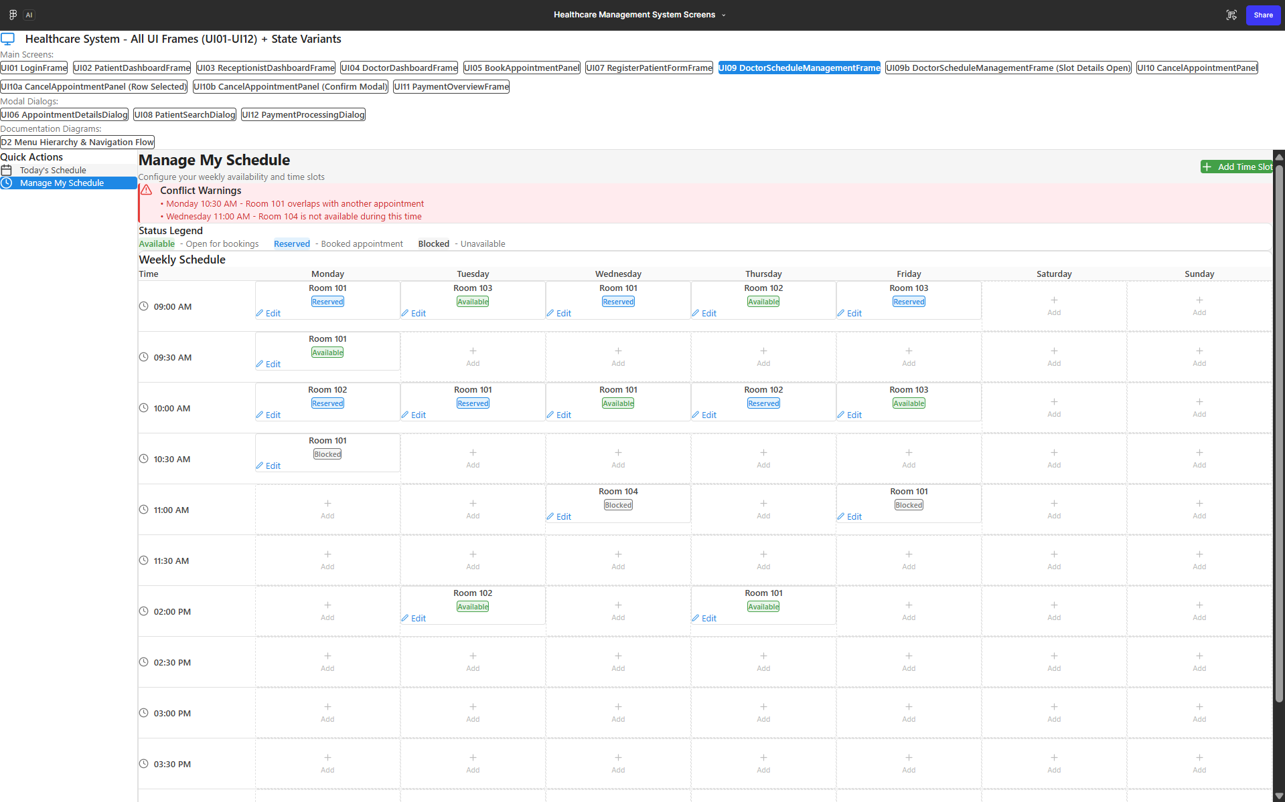

Figure 10: UI09b – Slot Details Open (State Variant) (Figma)
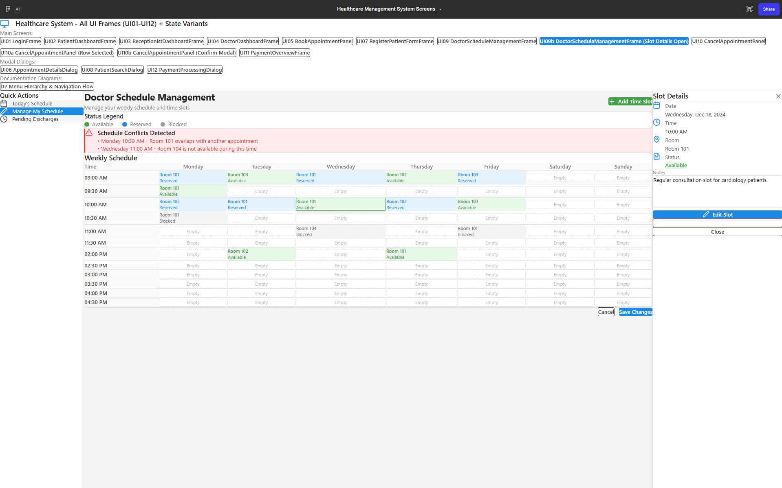

UC-06 Cancel Appointment flow

Figure 11: UI10 – CancelAppointmentPanel (No Selection State) (Figma)
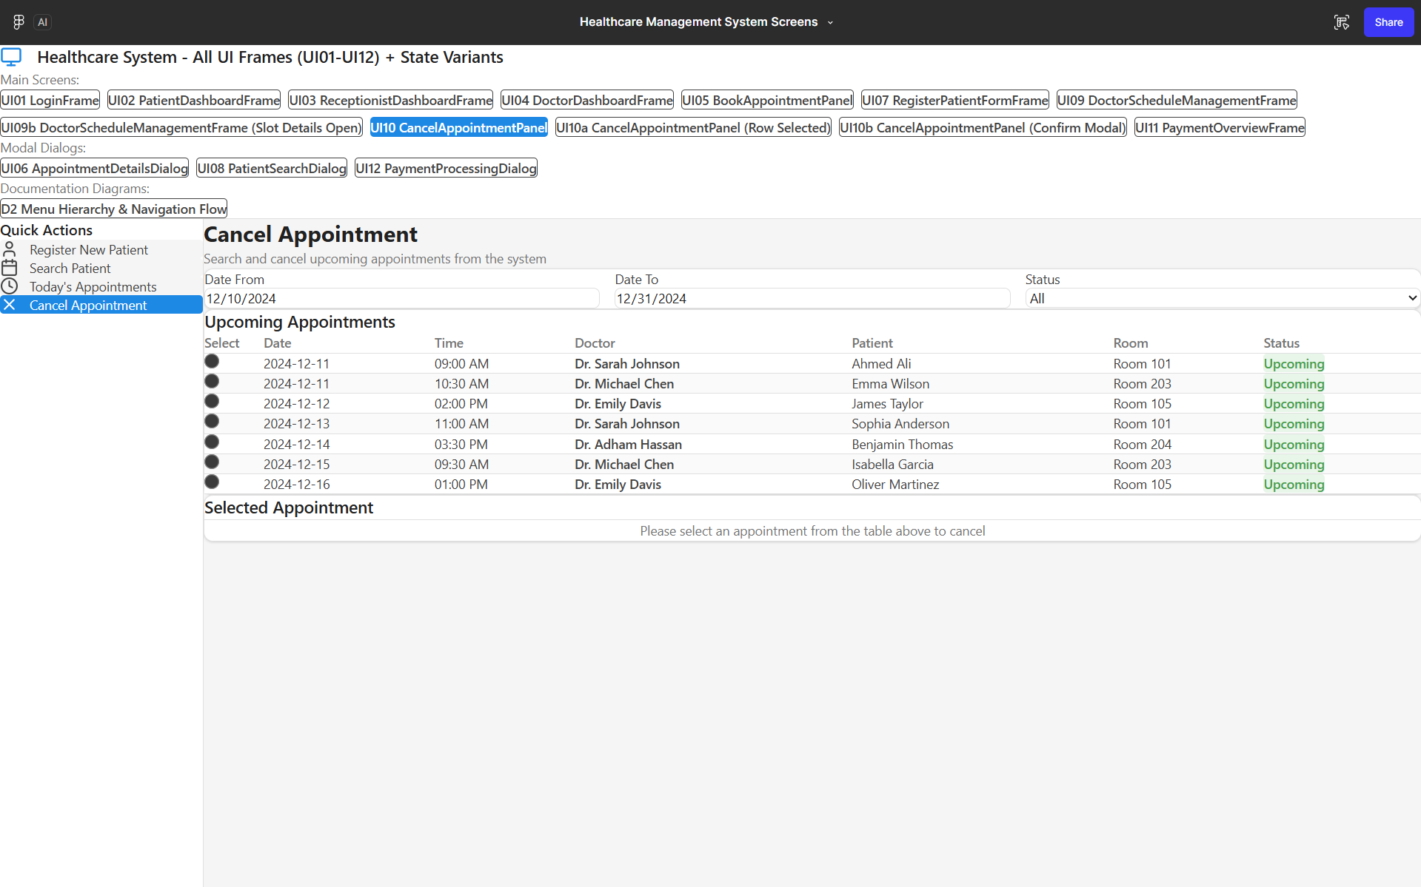

Figure 12: UI10a – CancelAppointmentPanel (Row Selected State Variant) (Figma)
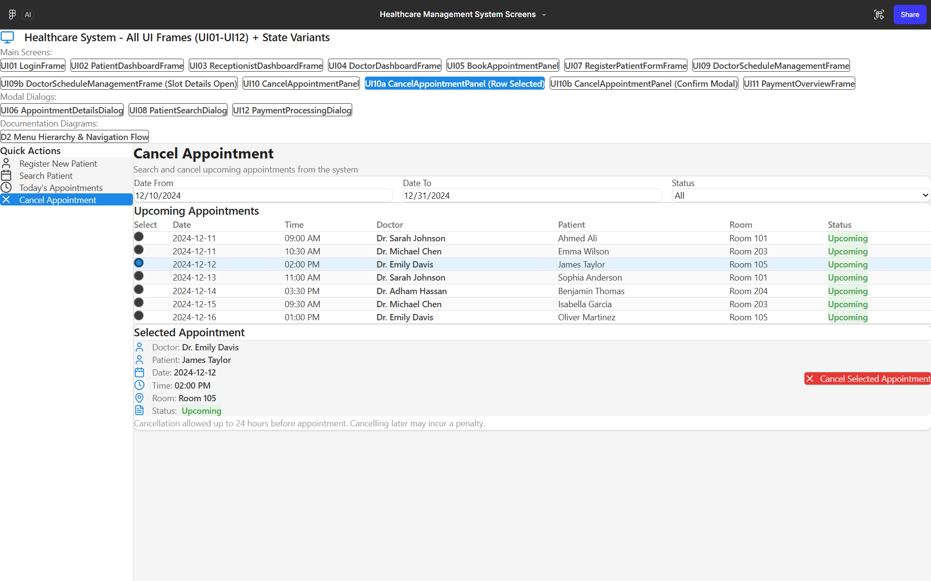

Figure 13: : UI10a- CancelAppointmentPanel(Confirm Modal) (Figma)
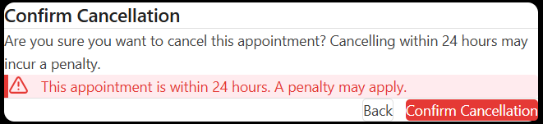

UC-07 Make Payment flow

Figure 14: UI11 – PaymentOverviewFrame (Figma)
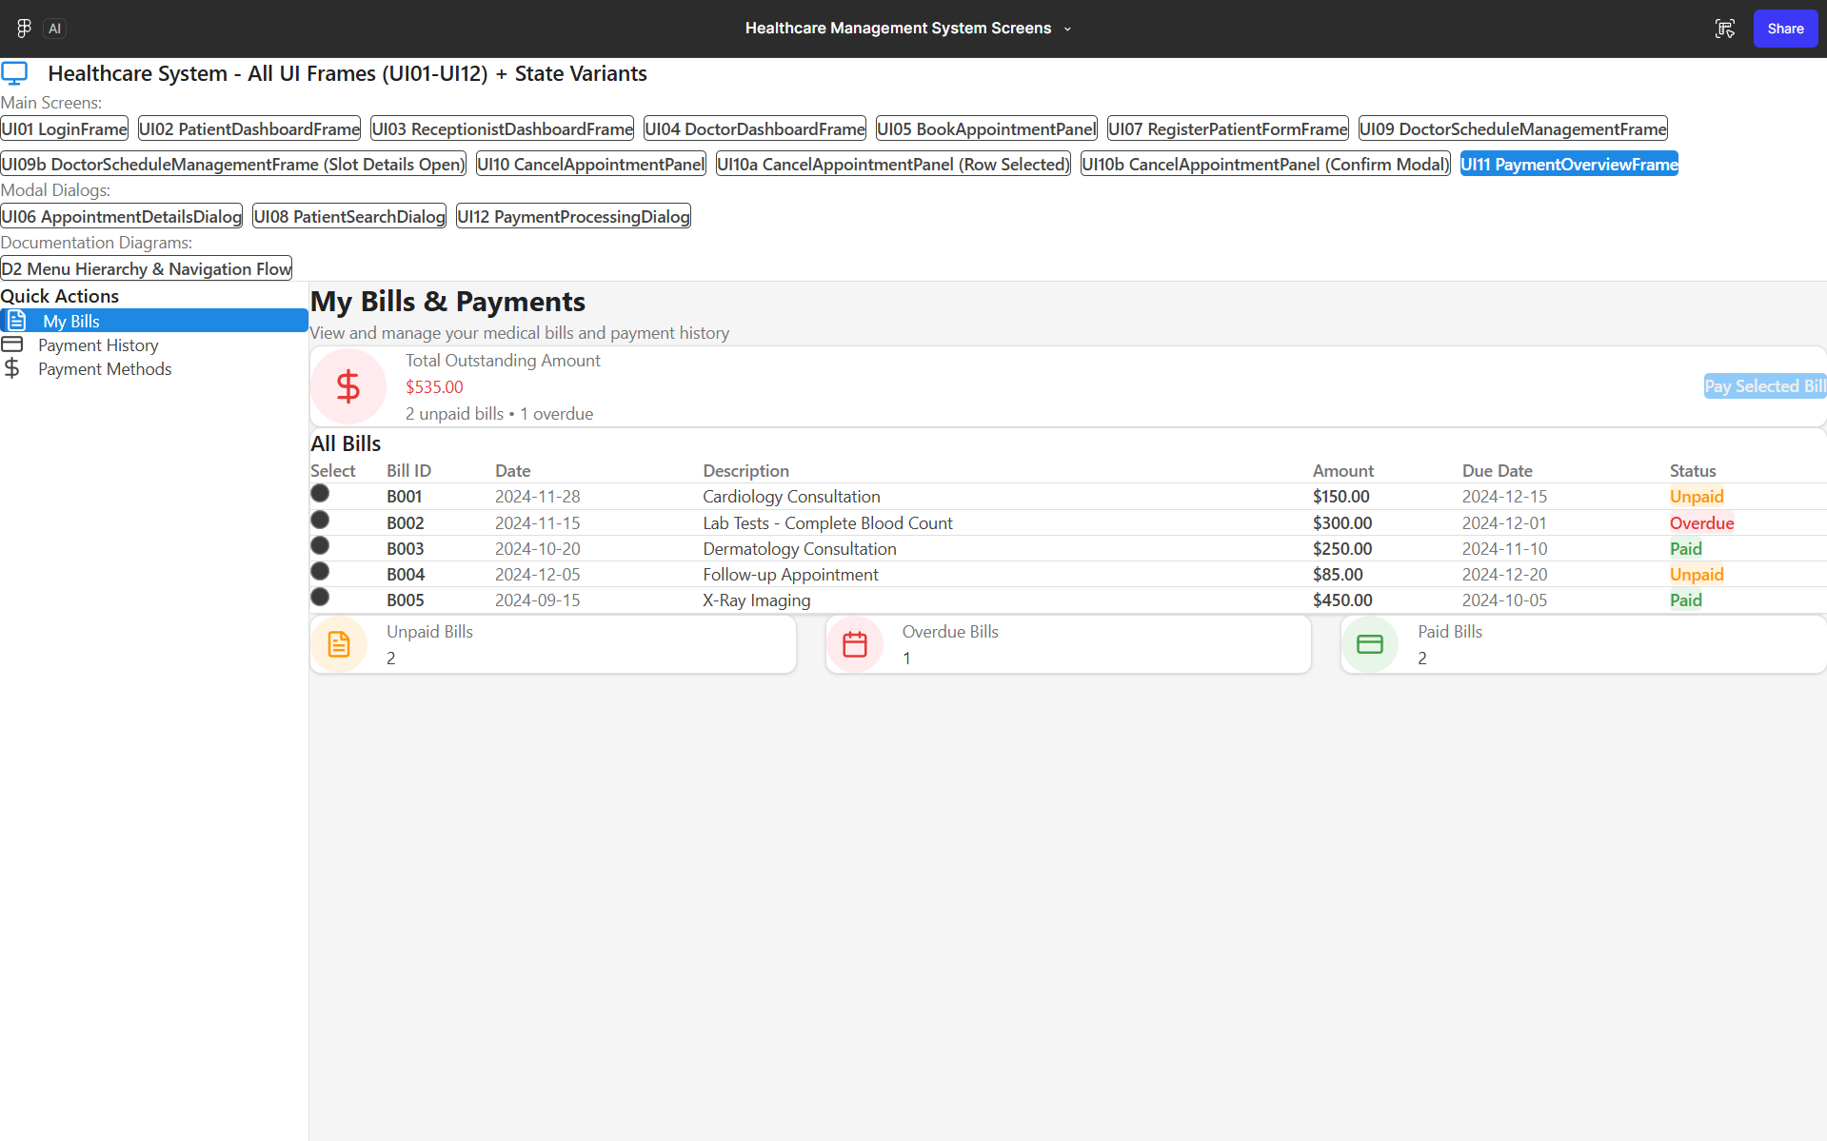

Figure 15: UI12 – PaymentProcessingDialog (Figma)
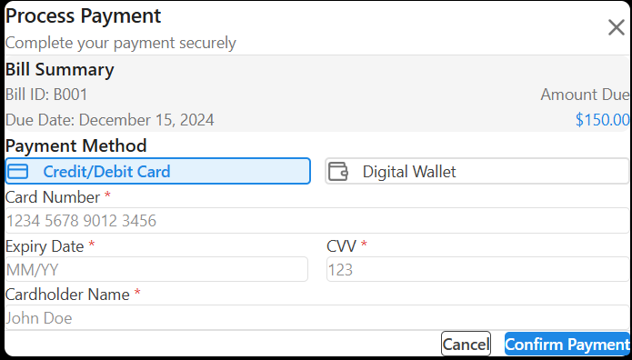

Jira Management
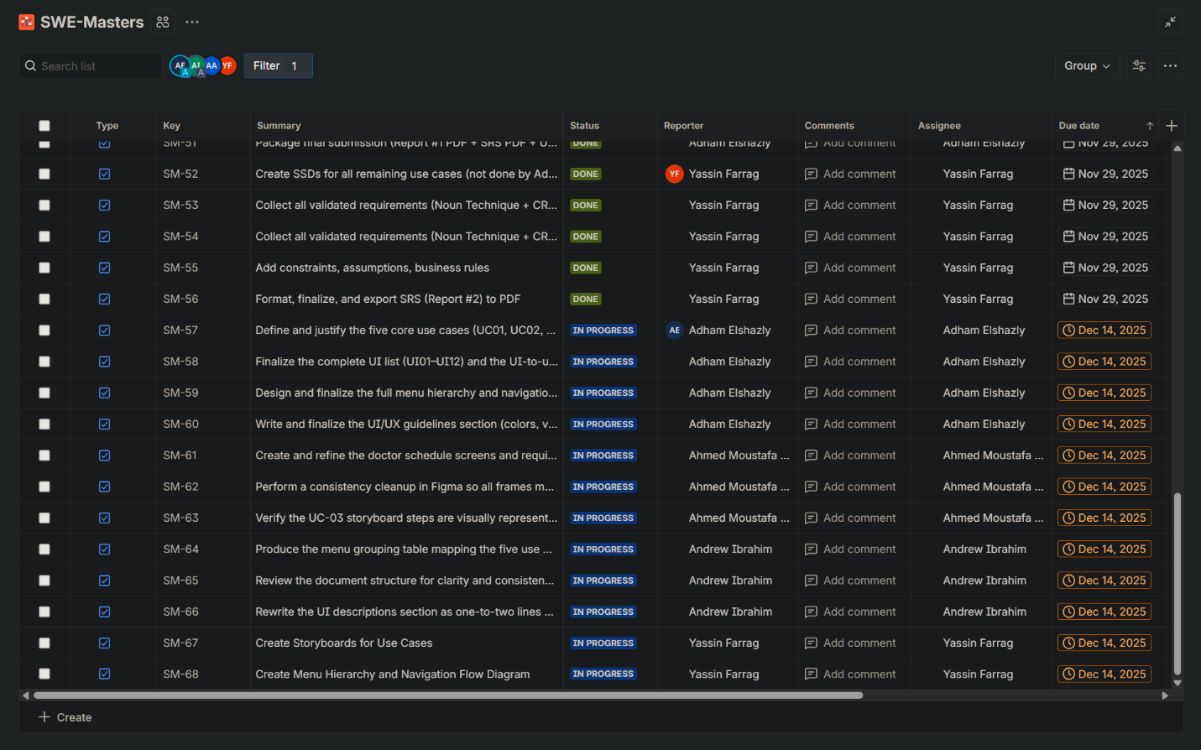
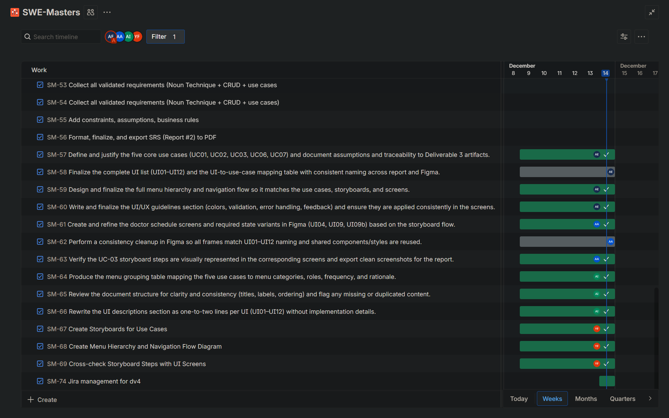
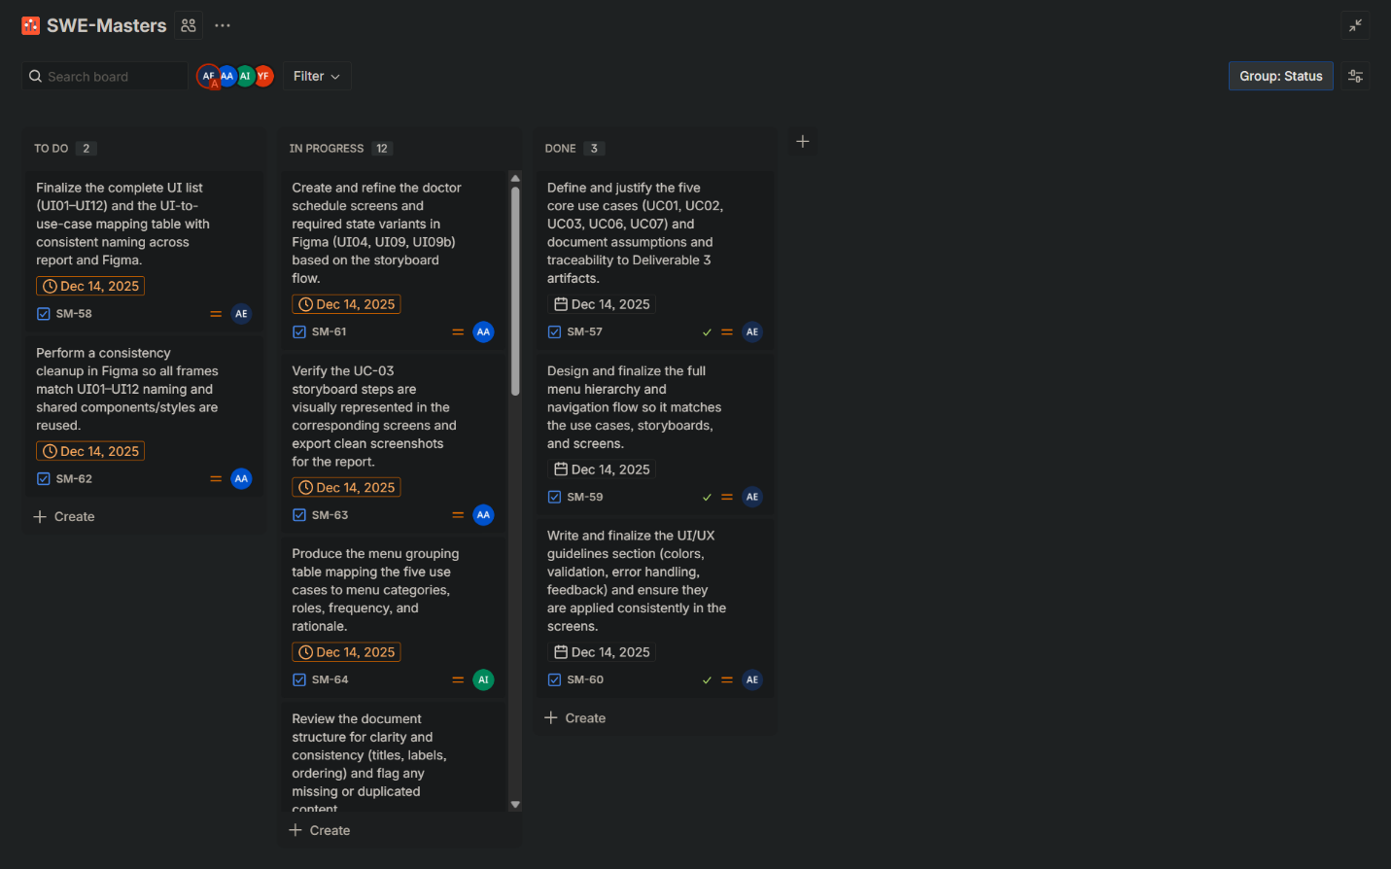

Github
https://github.com/Adhams01/Introduction-To-Software-Engineering-Project

